EXPERIMENT 8

SAILOR BOAT DATABASE (DDL, DML, DQL, Subquery, Joins, Set operations)

Aim:

* Create sailors, boats, and reserves.(foreign key)
* Insert 5 values each table.
* Display all records.
* Find the names and ages of all sailors.
* Find all sailors with ratings above 8.
* Find sailors name with rating above 7 & age above 25.
* Display all the names & colors of the boats.
* Find all the boats with Red colors.
* Find the names of sailors' who have reserved boat number 101.
* Find the sids of sailors who have reserved red boat
* Find the names of sailors' who have reserved Red boat.
* Find the colours of boats reserved by some Lubber.
* Find the names of the sailors who have reserved at least one boat.
* Find the names of the sailors who have reserved two different boats.
* Find the names of sailors who have reserved a Red or a Green boat.(union)
* Find the names of sailors who have reserved both a Red and a Green boat.
* Find the names of sailors who have reserved boat 103.(nested query)
* Find the names of sailors who have reserved red boat.(nq)
* Find the names of sailors who have not reserved red boat.(nq)
* Find the names of sailors who have reserved boat number 103.(exists)
* Find sailors whose rating is better than some sailors called name.
* Find sailors whose rating is better than every sailor' called name.
* Find the sailors with highest rating.
* Find the average age of all sailors.
* Find the average age of sailors with a rating of 10.
* Count the number of sailors.
* Count the number of different sailor ratings.
* Find the name and age of the oldest sailor.
* Find the names of the sailors who are older than the oldest sailor with a rating of 10.
* Find the age of youngest sailor for each rating level.
* Find the age of the youngest sailor who is eligible to vote (i.e., is at least 18 years old) for each rating level with at least two such sailors.
* For each red boat, find the number of reservations for this boat.
* Find all sailors name according to names.
* Find all sailors details according to rating.
* Find all sailors details according to rating(highest first) if ratings are same then according to age(youngest first).

**Procedure:**

**Code:**

* **CREATE SCHEMA sailor_boat;**
* **CREATE TABLE sailors(sid integer , sname varchar(50), rating integer, age real,**
* **constraint pk_sailors primary key(sid));**
* **CREATE TABLE boats(bid integer, bname varchar(50), color varchar(50),**
* **constraint pk_boats primary key(bid));**
* **CREATE TABLE reserves(sid integer, bid integer, day date, constraint pk_reserves primary key(sid, bid, day),**
* **constraint fk_sid foreign key (sid) references sailors(sid) ON DELETE CASCADE,**
* **constraint fk_bid foreign key(bid) references boats(bid) ON DELETE CASCADE);**
* **desc sailors;**
* **desc boats;**
* **desc reserves;**

**Outputs:**

**Sailor table**

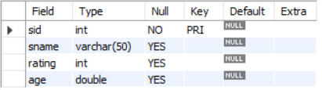

**Boat table**

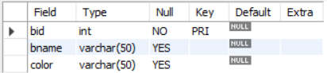

**Reserves table**

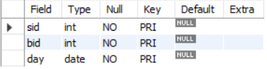

**Code:**

* **INSERT INTO sailors values(22, 'Dustin', 7, 45);**
* **INSERT INTO sailors values(29, 'Brutus', 1, 33);**
* **INSERT INTO sailors values(31, 'Lubber', 8, 55.5);**
* **INSERT INTO sailors values(32, 'Andy', 8, 25.5);**
* **INSERT INTO sailors values(58, 'Rusty', 10, 35);**
* **INSERT INTO sailors values(64, 'Horatio', 7, 35);**
* **INSERT INTO sailors values(71, 'Zorba', 10, 16);**
* **INSERT INTO sailors values(74, 'Horatio', 9, 40);**
* **INSERT INTO sailors values(85, 'Art', 3, 25.5);**
* **INSERT INTO sailors values(95, 'Bob', 3, 63.5);**
* **INSERT INTO boats values(101, 'Interlake', 'blue');**
* **INSERT INTO boats values(102, 'Interlake', 'red');**
* **INSERT INTO boats values(103, 'Clipper', 'green');**
* **INSERT INTO boats values(104, 'Marine', 'red');**
* **INSERT INTO reserves values(22, 101, '1998-10-10');**
* **INSERT INTO reserves values(22, 102, '1998-10-10');**
* **INSERT INTO reserves values(22, 103, '1998-10-8');**
* **INSERT INTO reserves values(22, 104, '1998-10-7');**
* **INSERT INTO reserves values(31, 102, '1998-11-10');**
* **INSERT INTO reserves values(31, 103, '1998-11-6');**
* **INSERT INTO reserves values(31, 104, '1998-11-12');**
* **INSERT INTO reserves values(64, 101, '1998-9-5');**
* **INSERT INTO reserves values(64, 102, '1998-9-8');**
* **INSERT INTO reserves values(74, 103, '1998-9-8');**

**Output:**

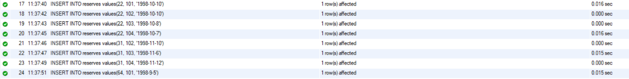





**Code:**

* **SELECT * from sailors;**
* **SELECT * from boats;**
* **SELECT * from reserves;**

**Output:**

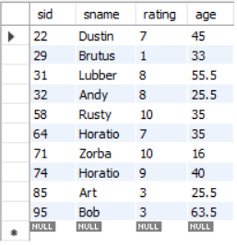

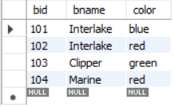

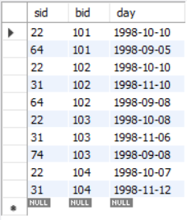

**Code:**

* **SELECT sname, age from sailors;**

**Output:**

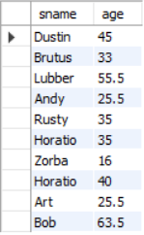

**Code:**

* **SELECT * from sailors where rating > 8;**

**Output:**

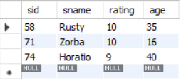

**Code:**

* **SELECT sname from sailors where rating > 7 and age > 25;**

**Output:**

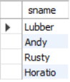

**Code:**

* **SELECT bname, color from boats;**

**Output:**

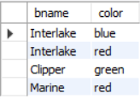

**Code:**

* **SELECT * from boats where color = 'red';**

**Output:**

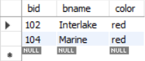

**Code:**

* **SELECT sailors.sname from sailors inner join reserves on sailors.sid = reserves.sid where reserves.bid = 101;**

**Output:**

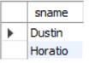

**Code:**

* **select distinct s.sid from sailors s, reserves r, boats b where s.sid = r.sid and r.bid = b.bid and b.color = 'red';**

**Output:**

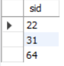

**Code:**

* **SELECT s.sname from sailors s, boats b, reserves r where b.color = 'red' and b.bid = r.bid and r.sid = s.sid;**

**Output:**

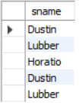

**Code:**

* **select distinct b.color from boats b where b.bid in (select r.bid from reserves r where r.sid in (select s.sid from sailors s where s.sname = "Lubber"));**

**Output:**

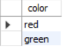

**Code:**

* **select distinct s.sname from sailors s, reserves r where s.sid = r.sid;**

**Output:**

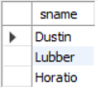

**Code:**

* **select s.sname from sailors s where s.sid in (select sid from reserves group by sid having count(DISTINCT bid) = 2);**

**Output:**



**Code:**

* **select Distinct s.sname from sailors s, reserves r, boats b where s.sid = r.sid and r.bid = b.bid and b.color = 'red' union select Distinct s.sname from sailors s, reserves r, boats b where s.sid = r.sid and r.bid = b.bid and b.color = 'green';**

**Output:**

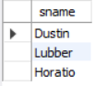

**Code:**

* **SELECT sname from sailors where sid in (SELECT r.sid from reserves r, boats b where b.color = 'red' and b.bid = r.bid and r.sid in (SELECT r.sid from reserves r, boats b where b.color = 'green' and b.bid = r.bid));**

**Output:**

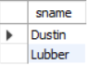

**Code:**

* **select s.sname from sailors s, reserves r where s.sid = r.sid and r.bid = 103;**

**Output:**

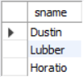

**Code:**

* **SELECT s.sname from sailors s where s.sid in (SELECT r.sid from reserves r where r.bid in (SELECT b.bid from boats b where b.color = 'red'));**

**Output:**

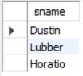

**Code:**

* **select s.sname from sailors s where s.sid not in (SELECT r.sid from reserves r where r.bid in (SELECT b.bid from boats b where b.color = 'red'));**

**Output:**

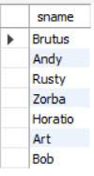

**Code:**

* **select sname from sailors where exists (select sid from reserves where bid = 103 and reserves.sid = sailors.sid);**

**Output:**

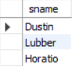

**Code:**

* **select sname from sailors where rating > any (select rating from sailors where sname = 'Dustin');**

**Output:**

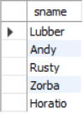

**Code:**

* **select sname, rating from sailors where rating >= all (select rating from sailors);**

**Output:**

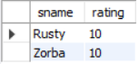

**Code:**

* **select sname, rating from sailors where rating in (select max(rating) from sailors);**

**Output:**

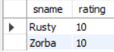

**Code:**

* **select avg(age) from sailors;**

**Output:**



**Code:**

* **select avg(age) from sailors where rating = 10;**

**Output:**



**Code:**

* **select count(sid) from sailors;**

**Output:**



**Code:**

* **select count(distinct rating) from sailors;**

**Output:**

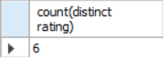

**Code:**

* **select sname, age from sailors where age = all(select max(age) from sailors);**

**Output:**



**Code:**

* **select sname, age, rating from sailors where rating = 10 ;**

**Output:**

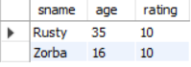

**Code:**

* **select rating, min(age) from sailors group by rating order by rating desc;**

**Output:**

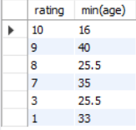

**Code:**

* **select min(age) from sailors where age >= 18;**

**Output:**



**Code:**

* **create view redBoat as select bid, bname, color from boats join reserves using(bid) where boats.color = 'red' ;**
* **select distinct bid, bname, color, count(bname) from redBoat group by bid;**

**Output:**

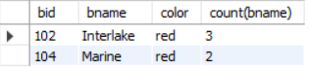

**Code:**

* **select sname from sailors order by sname asc;**

**Output:**

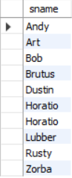

**Code:**

* **create view sailorReserves as select distinct * from sailors left join reserves using(sid);**
* **create view sailorReserveBoat as select distinct * from sailorReserves left join boats using(bid);**
* **select * from sailorReserveBoat order by rating desc;**

**Output:**

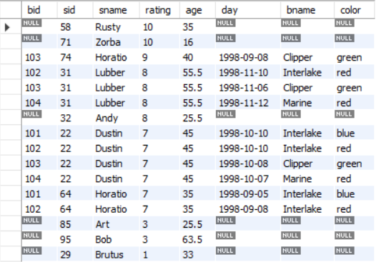

**Code:**

* **select * from sailorReserveBoat order by rating desc, age asc;**

**Output:**

